Advanced Computer Graphics

C417 – Spring 2013

01-03-2013 – Alexandre Camus

# Fresnel Reflectance

Here is the Fresnel reflectance of a dielectric material. Its index of refraction is . This gives the curve in Figure 1. It shows the Brewster’s angle which is, in this case, .

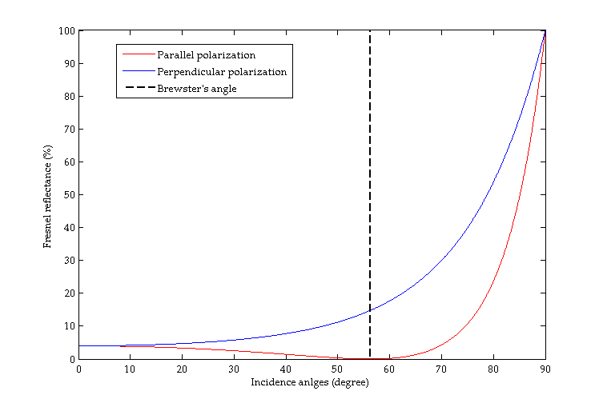

Figure 1: Fresnel Reflectance from air to dielectric material

And when the light does the way back, from the dielectric material to the air, the curve of the Fresnel reflectance is as in Figure 2. Again there is a particular angle: the critical angle which is here .

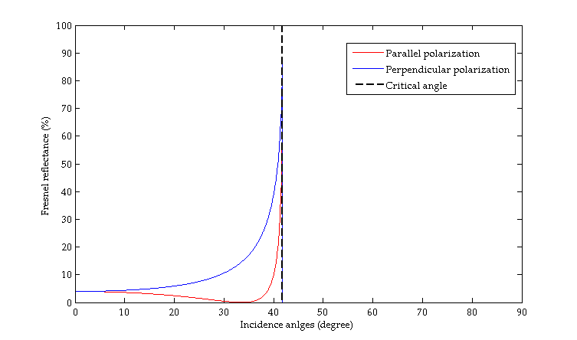

Figure 2: Fresnel Reflectance from dielectric material to air

# Samples according to an Environment Map

Based on the following technics, I sampled 1024, 256 and 64 lights on the Environment Map as shown in Figure 3, Figure 4 and Figure 5. In the Zip file they are stored in em_numberOfSamples.

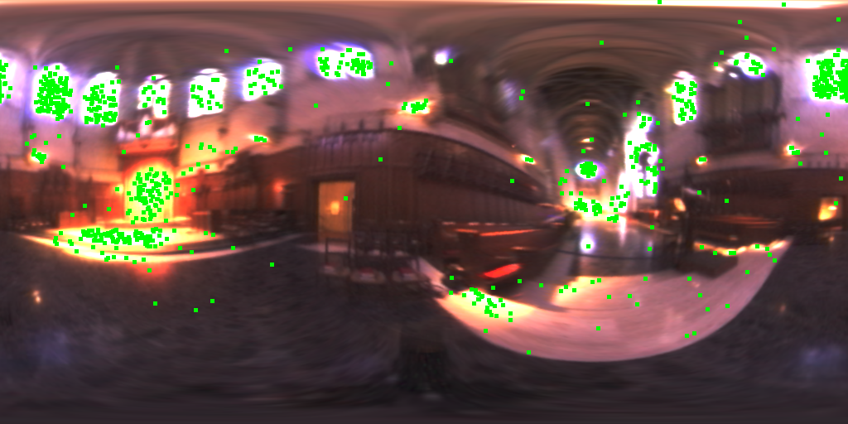

Figure 3: 1024 samples according to the Grace Cathedral Environment Map

The technics is simple. First I computed the average luminance of each rows of the Environment Map to create a vertical PDF. Based on these averages, I sampled the ordinate of each sample. Then the ordinate gave me the row on which I applied the same sampling based on the PDF of this very row. This gave me the abscissa of the sample. Then I simply coloured a green square centred on the sample.

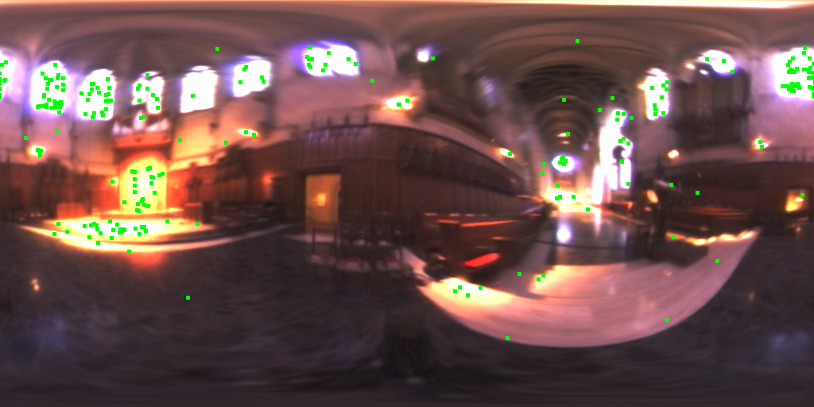

Figure 4: 256 samples according to the Grace Cathedral Environment Map

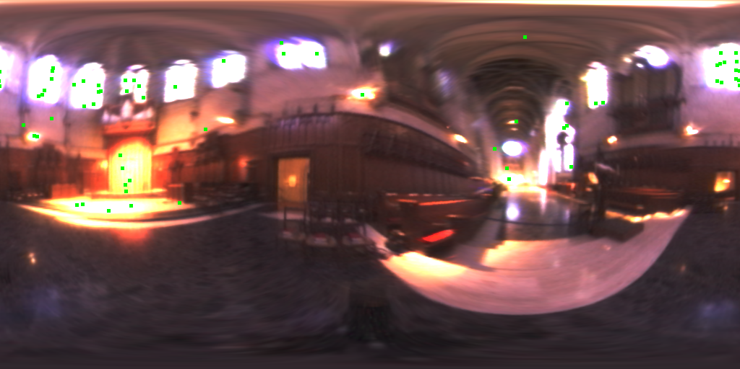

Figure 5: 64 samples according to the Grace Cathedral Environment Map

The light sources are mostly in the most luminous areas of the Environment Map and take into account the since the light at the very top of the map is not (or less) represented. In the test I did without the , it was.

# Samples according to the Phong BRDF

This sampling method isn’t based on the source. It is based on only the shape of the object we want to artificially illuminate. This need a direction from where the object is watched. Then based on the Phong model of reflectance, the algorithm computes sample to match the model.

The results (with 1024 samples) are shown in Figure 6, Figure 7, Figure 8 and Figure 9. In the Zip file they are stored in phong_exponentS.

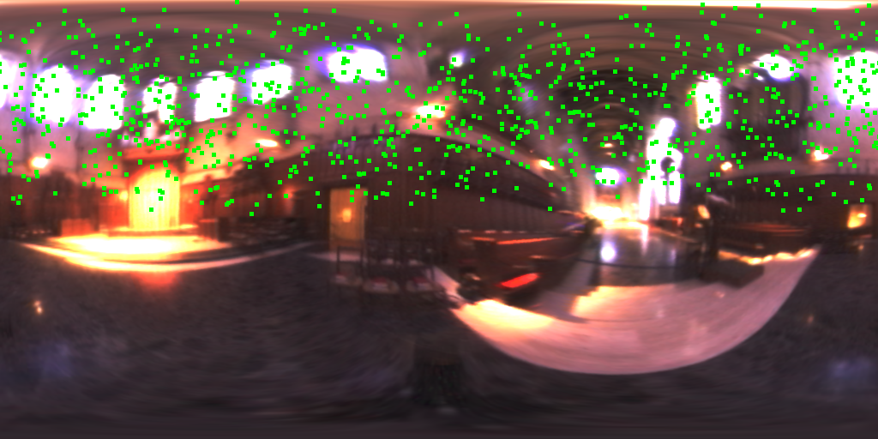

Figure 6: Samples according to Phong BRDF,

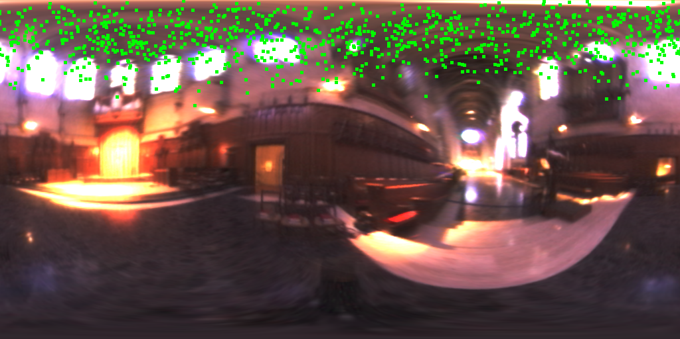

Figure 7: Samples according to Phong BRDF,

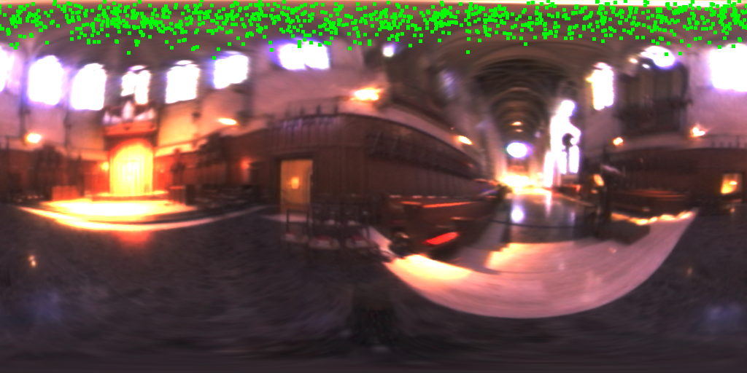

Figure 8: Samples according to Phong BRDF,

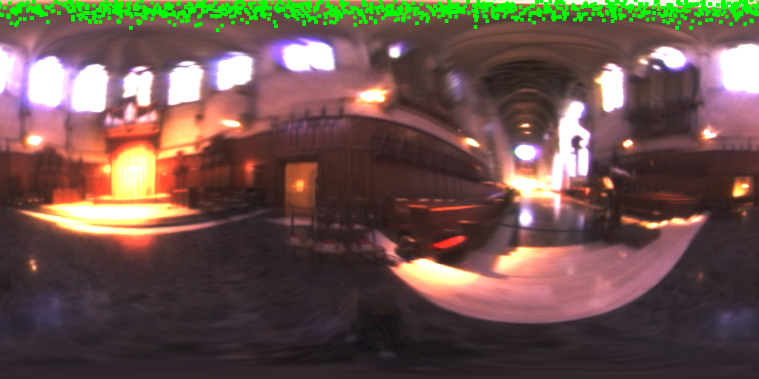

Figure 9: Samples according to Phong BRDF,

# Rendering

This is based on the following formula:

where and . We must also ignore a negative value of since it means that the sample is in the back of the sphere.

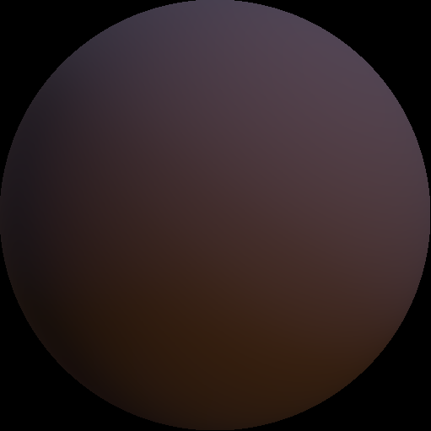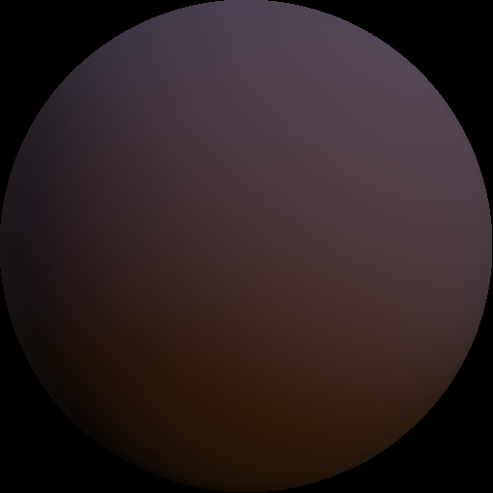Then I computed it. The results I got seem quite accurate. The sphere is relighted by the first half of the latitude-longitude image, which means that the view point is at . They are shown on Figure 10, Figure 11 and Figure 12. In the Zip file they are stored in sphere_numberOfSamples.

Figure 10: Render with 64 samples

Figure 11: Render with 256 samples

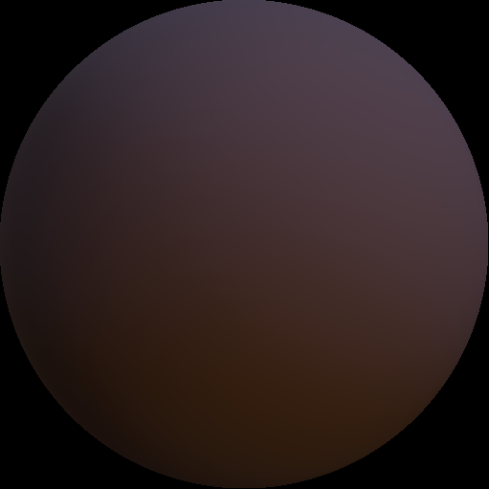

Figure 12: Render with 1024 samples